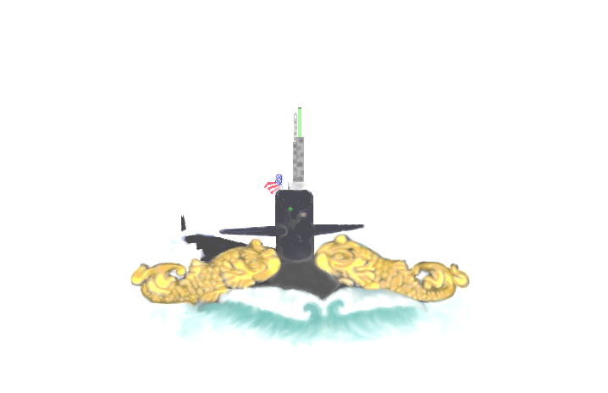

SUBMARINE FORCE

To all those who see these presents, greetings

Know ye, that in special recognition of the personal character and abilities of

Who, as the devoted wife of a Submariner in good standing, has repeatedly demonstrated her patriotism, loyalty, fortitude and a continuing love and esteem for Submariners, and has frequently contributed to the morale of the Submarine Force by her cheerful willingness to render assistance to the families of other Submariners when in need, I do herewith appoint her, by and with the consent of officers and men of the aforesaid force, a

Submarine Lady of the Submarine Force

Know ye throughout the United States Navy that, as a special mark of our gratitude, she is entitled to wear the Submarine insignia. Further, she is entitled to all privileges of a Submarine Lady, and I do strictly charge and require all members of the Submarine Force to render her every courtesy, and their highest esteem, and I do encourage them to assist her in any manner within their capabilities whenever the opportunity arises, by the normal tenets of chivalry or by actual necessity.

"For though at sea her spouse may roam,
She valiantly serves her ship at home."

Done, on this day of , in the year of our Lord

Commander, U. S. Navy
Commanding Officer

