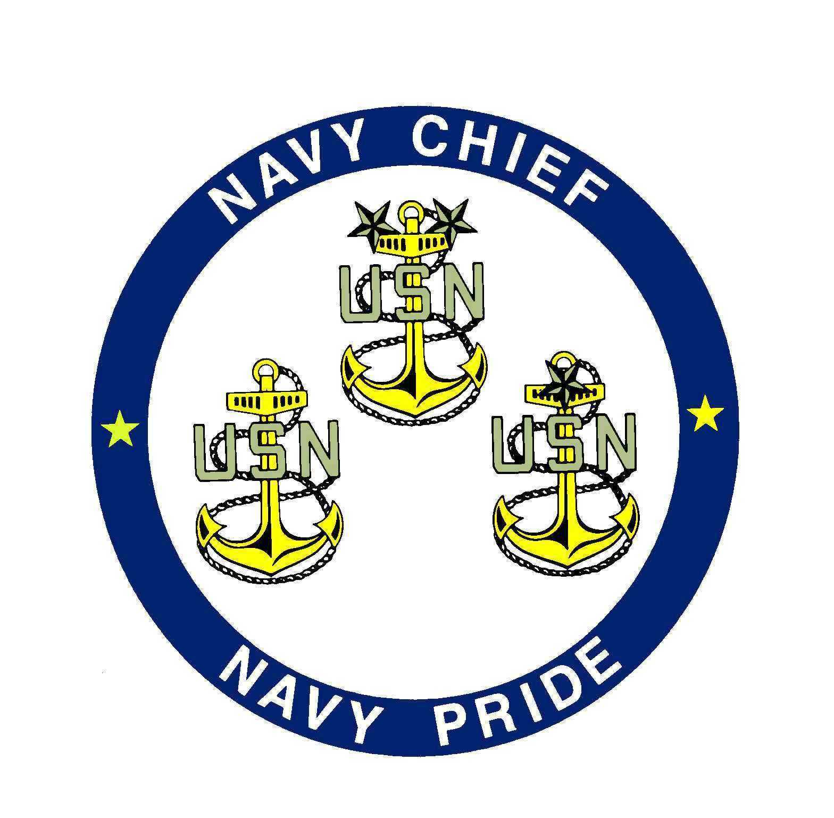
Guiding Principles
Of the Chief Petty Officer

No person is more professional than I. I AM A Chief Petty Officer, a leader of people. As a Chief Petty Officer, I realize that my number one priority is to accomplish the mission.

I am proud to be a Chief Petty Officer and will at all times conduct myself as to bring credit upon the command the Navy my country and myself. I will accept responsibility of and accountability for my actions. I will do "what is right" based on individual circumstances.

Competence is my watchword. I will strive to remain technically and tactfully proficient. All sailors are entitled to outstanding leadership; I will provide that leadership. I know my people and will always place their needs above my own. I will communicate consistently with my people, be fair and impartial when recommending both awards and punishment. I will train, guide and mold junior officers. I will evaluate people based on personal worth.

As a Chief Petty Officer I will work to earn the respect and confidence of officers and my people. I will be loyal to those with whom I serve; seniors, peers and subordinates alike. I will exercise initiative, by taking appropriate action in the absence of orders. I will not compromise my integrity, nor my moral courage. I will not forget, nor will I allow my comrades to forget, that we are professional Chief Petty Officers.

-Leaders of people

Anonymous

