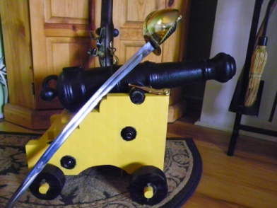
THE NAVAL GUN FOR CEREMONY AND DEMONSTRATION.
By MCC Leif HerrGesell
In May of 2010 before deploying to Afghanistan I was asked to be the emcee and sponsor for a retiring Bull First. Our reserve center has a long tradition of doing retirements RIGHT! Since it was my honor to help a shipmate go ashore, I decided to do something different and with the permission of our NOSC CO and the local constabulary. I asked a local Revolutionary War re-enactor if he could help me out and provide a naval gun to render a single shot as our Shipmate was piped ashore.
My contact provided a ½ scale bronze gun mounted on a naval truck. At the end of the 45 min ceremony he fired a single round from the gun, termed a “murderer”. The guns total weight was 80lbs, but its report was anything but small. No windows were broken or car alarms set off, but it was a sight to behold.
The response by troops, visitors and a Rear Admiral who was on deck was overwhelming.
I reported to NMCB 18 just days later. While in Gulfport taking classes, one of my troops, an EO1 Spooner who was filling the lead MA billet, told me an iron foundry in Idaho that casts historic artillery tubes. After a few weeks of thought I bought the 5/8 scale cast iron barrel pictured on the next page. I made the purchase just 48hrs before we left for Afghanistan. I had the barrel to my home in upstate New York and it arrived in the late summer.
I came home 8 mos later and the rest is history. I personally own the gun, but am making it available to our Mess, Sailors and NOSC for ceremonial use. All of the research on the carriage and the instructions for an authentic naval truck came from a book I ordered while at Kandahar Air Field. This gun when complete can be used for teaching naval heritage with both Sailors and Chief Selects, fired for ceremonial purposes and will make any Mess spaces the envy of visiting Goats.
Those Chiefs and Sailors living in the interior of the country will find this project especially useful since trips to the Constitution or an 18th century fortification are less readily available. Any discussion of 18th century gunnery should automatically segue to discussion of ships, their size, number of guns, fleet and squadron maneuvers in battle and the daily life and skills of our service branches personnel in the age of sail. Manning the gun with a Chief and three Sailors plus a back up crew in case of absences provides hands on heritage training, leadership and a deep appreciation of ceremony and military bearing. You can literally bring the gundeck of the Constitution into your station for less than a set of travel orders. Command approval and the cooperation of the safety officer are essential along with ORM and good solid deckplate leadership.
The total cost in 2011 dollars is around $400 for the barrel, hardware and lumber. Finished weight of my gun is around 100lbs and even fully assembled will ride in the back seat of a normal family car- no child safety seat required for this baby. The bore is 1.5inches making it 1.50cal or about a 1 pounder. I will not give any advice on drilling the touch hole or working up a load, but there is ample material on these subjects available on the internet.
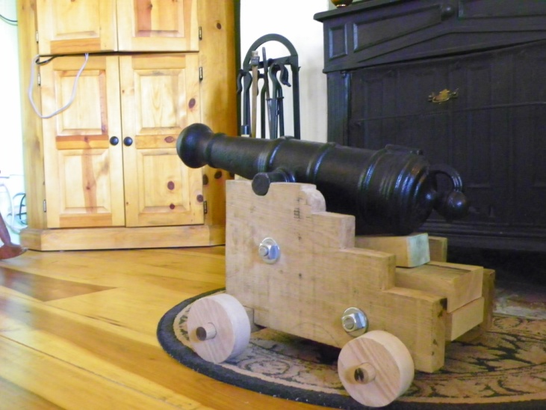
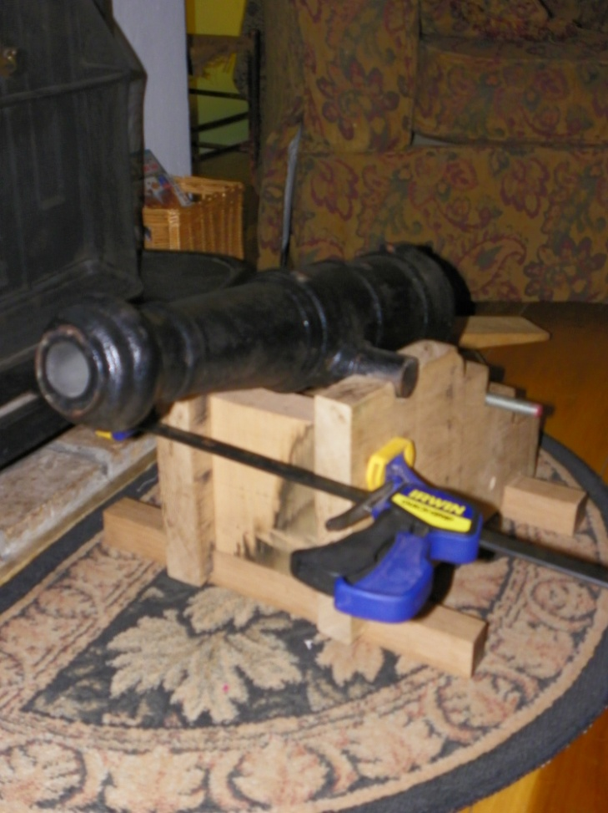
My only cautionary is this: Guns grow in size exponentially- the jump from this small gun to a 3pounder results in the 3pndr weighing in at around 500lbs for barrel and carriage- no small piece of artillery to transport and handle as well as man- but if you’ve got the resources, what a project for our Sailors and what a tribute for the coming War of 1812 bicentennial!

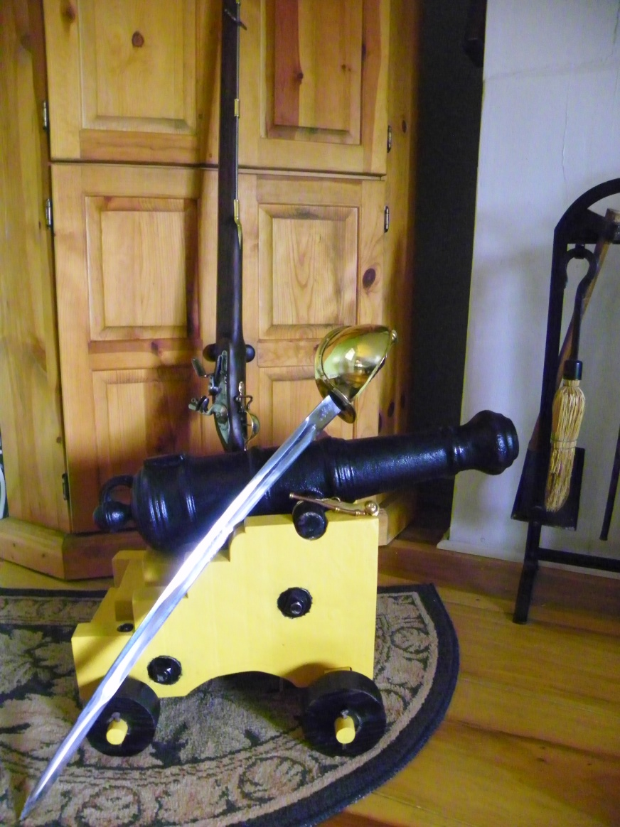
To the left and above we see the gun in stages of construction. The lower left picture shows the gun ninety percent finished only waiting for the cap squares for the trunnions. Note items in the image for scale reference.

Tools for this project are outlined in the book by Damian Siekonic. Most shops will have the basics of a circular saw, jig saw, chisels, hand drill, hand saw, rasps, hacksaw and clamps. Larger guns will require additional tool resources and are a difficult job for one Chief.
Cap squares to trap the trunnions and secure them to the carriage will require a tool and die or fabrication shop or a blacksmith. Mine were made by a blacksmith- all other hardware was commercially available as was the rough-cut lumber. I decided to use the traditional oak, however, maple also makes a good carriage. My experience in building custom flintlocks and other projects was invaluable, but this can be done by a patient and careful novice.

