CERTIFICATE OF APPRECIATION
from

THE UNITED STATES NAVY

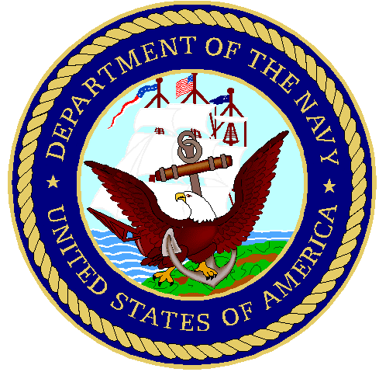

To all who shall
See these presents, greetings:
To
_______________________

Has earned grateful appreciation for his unselfish, faithful, and devoted service during his father’s naval career. His unfailing support and understanding helped to make possible his father’s lasting contribution to the nation.

Given this eighteenth day of August, in the year of our Lord, two thousand six.

_______________________
Captain, U.S. Navy
Commander
Naval Special Warfare Group FOUR

