CERTIFICATE OF APPRECIATION
from

THE UNITED STATES NAVY

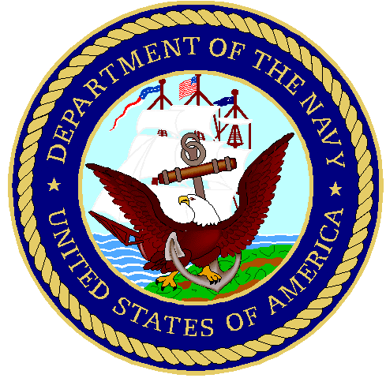

To all who shall
See these presents, greetings:
To
_______________________

By the authority vested in me, it is my pleasure to express the grateful appreciation of the United States Navy to you for enduring the frequent hardships in supporting your husband, Cecil, as he served his country. Cecil’s time away was instrumental in ensuring you and your family inherited a stronger Nation and a safer world. These months, indeed years that he spent away from you and your family, you provided Cecil with unwavering support and unconditional love. In Cecil's absence, you were both Mother and Father and responsible for the welfare and security of Luke. Your selfless dedication made certain of a stable home during a time of conflict and instability. The United States Navy thanks you for your many sacrifices and noble support to Cecil and our Nation.
Given this eighteenth day of August, in the year of our Lord, two thousand six.

_______________________
Captain, U.S. Navy
Commander
Naval Special Warfare Group FOUR

