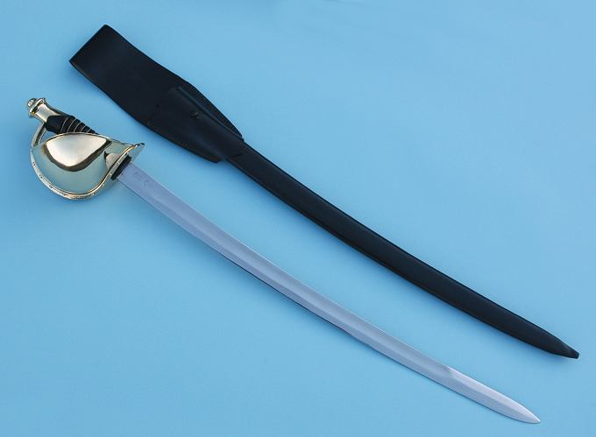

Presentation Of The Cutlass
By- MCC Leif HerrGesell

Seniority in the mess is measured by experience, heart and courage. The courage to do the right thing, the heart to care about all of your sailors equally, the experience to guide the young, mentor your replacements and to lead when and where others fear to go.

There are several symbols by which Chief Petty Officers are recognized. The most widely recognized is the anchors we wear. Many would also say it’s the battered combination cover that symbolizes the weathered, wisdom of a seasoned Chief.

There is another treasured symbol of the senior salt- one that harkens to the day of wooden ships and iron men. Our heritage recalls the days when the cry went up aboard sailing ships- “Boarders Away!” and a band of screaming, courageous blue jackets would storm the decks of an enemy man of war. At their head an intrepid officer- often the skipper himself and at his shoulder protecting him from harm and setting the example to his mates was a calm, rock hard sailor- perhaps the Captain of the topmast or the senior boatswains mate- today they would be called- CHIEF.

Chief Kinney front and center. Chief Aquilano, Chief Crowley please step forward.

In his hand that senior salt carried one of the most recognizable symbols of American Naval courage- a cutlass. The Chief Petty Officers Mess of Navy Operational Support Center Rochester presents to Chief Kinney this 1861 Ames pattern cutlass- identical to those carried by United States Navy sailors from the Civil War until the 1930’s. That sword was officially discontinued from service in 1949.

The Cutlass has been restored to its place of honor and is now a widely recognized symbol of the bravery of our Navy and of our Core Values of HONOR, COURAGE & COMITTMENT. The cutlass combined with the gold fouled anchor (surmounted by the silver letters U-S-N) are emblematic of the Chief Petty Officers Mess and represent all that our shipmate and brother Chief Joseph Kinney has and continues to stand for.

The inscription on the blade reads- Chief Joseph Aubrey Kinney III, Given by the Mess- May 3rd 2009.

