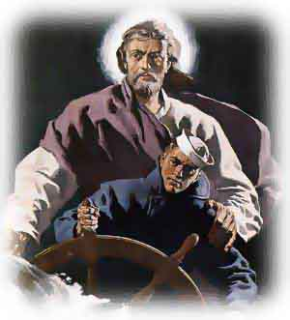
Mariner's 23rd Psalm
The Lord is my pilot, I shall not go adrift;
He lighteth my passage across dark channels;
He steereth me through the deep waters,
He keepeth my log.
He guideth me by the evening star for my safety's sake.
Yes, though I sail mid the thunders and tempests of life,
I fear no peril, for Thou art with me,
Thy stars and heavens, they comfort me.
The vastness of the sea upholds me.
Surely fair winds and safe harbors shall be found
All the days of my life;
And I shall dock, secure forever.
Amen

Retirement Ceremony

Command Master Chief

Francis Pula Nikolao

United States Navy

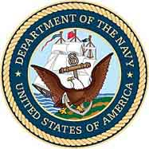

June 22nd, 2001

Anti-Submarine Warfare Base
Point Loma, San Diego, California
Admiral Kidd Club

