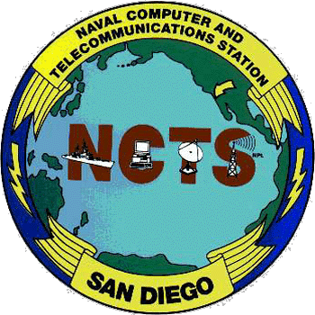

Biography CMDMC(SW) Francis P. Nikolao

Home Town: American Samoa
Spouse: Anna Marie Nikolao
Children: Daniella Marie Nikolao, Alexandria Francesca Nikolao, Mikaele Francis Nikolao

Master Chief Francis P. Nikolao is a native of Samoa. He enlisted as a Seaman Recruit in the United States Navy in his hometown of Pago Pago, American Samoa, in July of 1971.

Meritoriously advanced to E-2 during recruit training at Naval Training Center San Diego, California, he transferred to USS CONSTELLATION (CVA 64), homeport in San Diego. While attached to CONSTELLATION, he experienced two deployments to the Western Pacific, Gulf of Tonkin, Vietnam and a homeport change for dry-dock overall to the shipyard in Bremerton, Washington.

From 1975 to 1976, en-route for overseas assignments, he attended numerous schools including Communications Material Systems, advanced Radioman “C” school and Communications Systems Technical Schools.

In July of 1976 he reported to Naval Communications Station Philippines where he worked as a Technical Controller. From 1978-1981, as Second and First Class Petty Officer, he was the Quality Control Leading Petty Officer (LPO) for Technical Control Facility at Naval Communications Area Master Station Eastern Pacific, Hawaii.

Returning to San Diego from overseas in 1981, he was assigned to Commander Cruiser Destroyer Group Five Staff as the Radioman Leading Petty Officer (LPO). Promoted to Chief Petty Officer in 1984. In 1985 he reported as Chief Petty Officer In-Charge of the Military detachment on board USNS ZUES (T-ARC 5). In 1986 he reported to Naval and Marine Corps Reserve Readiness Center, San Diego, CA for assignment as Instructor, Communications Officer, Drug/Alcohol Program Advisor (DAPA), Senior Watch Officer, Security Officer and Physical Fitness Coordinator. Promoted to Senior Chief Petty Officer in 1988. In 1989 he reported to USS BARBOUR COUNTY (LST 1195) as Leading Chief Petty Officer (LCPO) for operations department. Promoted to Master Chief Petty Officer in 1991. In 1992 he was assigned to USS LONG BEACH (CGN 9) as LCPO for operations department. In 1993 he served as Department Master Chief for Engineering and Supply schools at Service School Command, San Diego, California. Selected for the Command Master Chief Program and attended the Senior Enlisted Academy in 1996. Completed three year Command Master Chief tour on board USS OGDEN (LPD 5) in 1999.

Master Chief Nikolao reported as Command Master Chief to Naval Computer and Telecommunications Station, San Diego in May 1999.

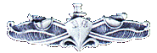
The Chief Petty Officer Retirement Creed
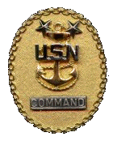
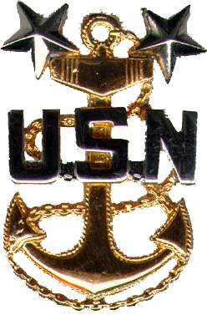
You have on this day, experienced that which comes to all of us who serve on active duty in "OUR NAVY." I say "OUR NAVY," because your departure from active duty in no way terminates your relationship. By law and tradition, U.S. Navy Retirees are always on the rolls ever ready to lend their service when the need arises. The respect that you earned as "The Chief" was based on the same attributes that you will now carry into retirement. You should have no regrets. Do not view your retirement as an end of an era but rather as orders to a new and challenging assignment, to a form of independent duty. Remember well that you have been, and will always be, an accepted member of the most exclusive of all fraternities - that of the U.S. Navy Chief Petty Officers. The active duty Chiefs salute you, your retired Chiefs welcome you. I wish you the traditional:
"Fair Winds and Following Seas."
